**Task 1:**

#include<iostream>

#include<cmath>

using namespace std;

bool isprime(int n);

int main(){

int n=2,sum=0,n1=1;

while(n1<=50){

if(isprime(n)){

sum+=n;

n1++;

}

n++;

}

cout<<"the sum of first 50 prime numbers is "<<sum;

}

bool isprime(int n){

for(int i=2;i<=sqrt(n);i++){

if(n%i==0){

return 0;

}

}

return 1;

}

**Output:**

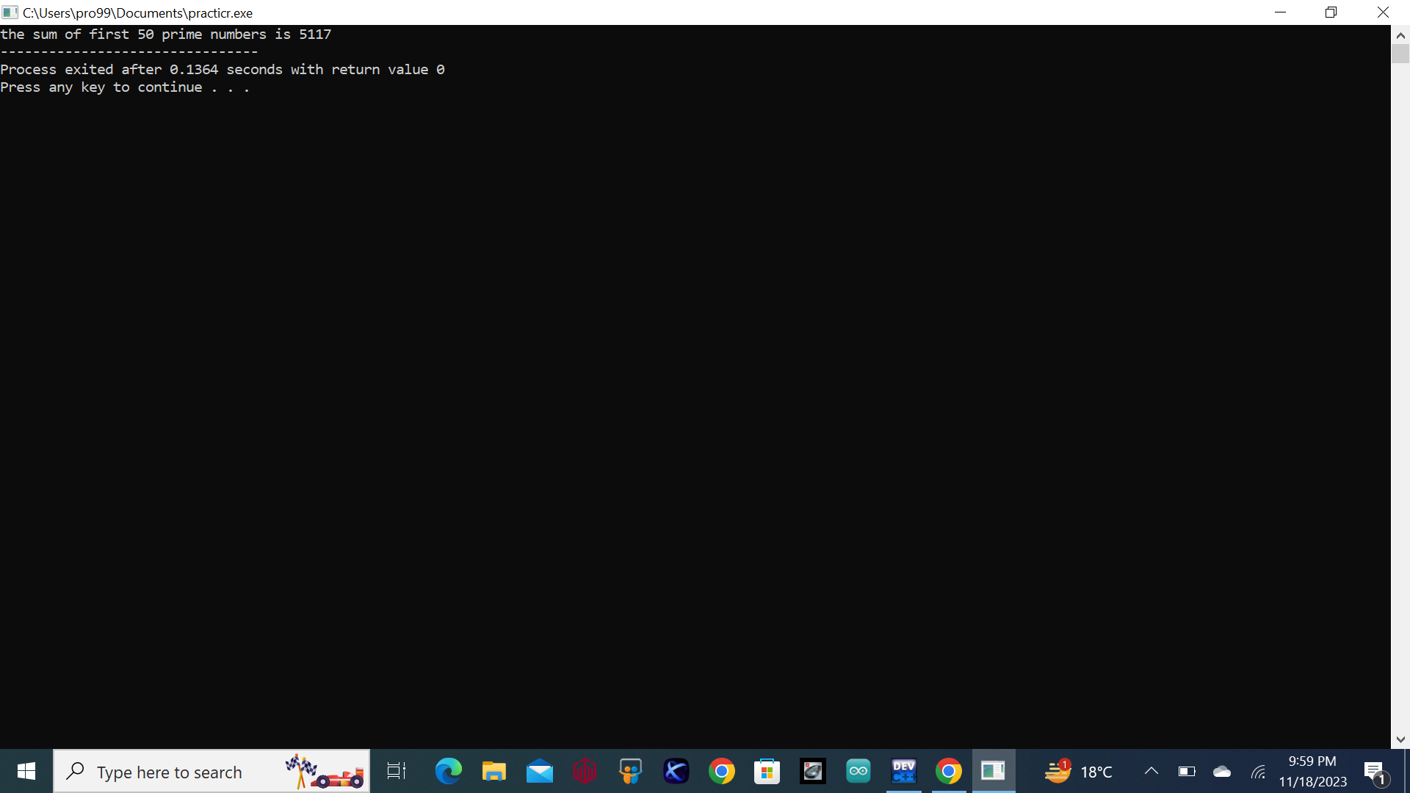

**Task 2:**

#include<iostream>

using namespace std;

int main(){

for(int i=1;i<=5;i++){

for(int k=1;k<=i;k++){

cout<<k<<" ";

}

cout<<endl;

}

**Output:**

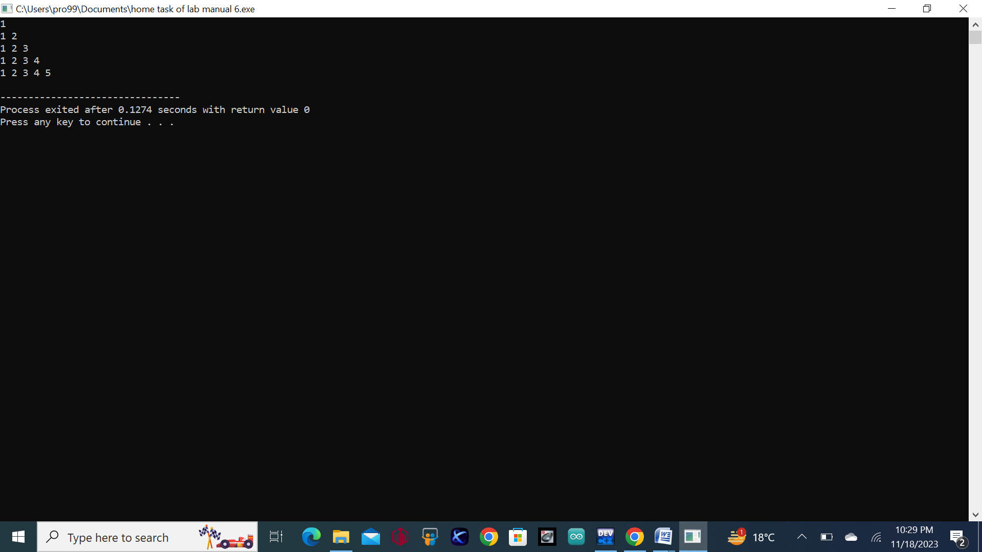

**Task 3:**

#include<iostream>

using namespace std;

int main(){

int num=2;

cout<<"1"<<endl;

for(int i=1;i<=3;i++){

for(int j=1;j<=i;j++){

cout<<num<<" "<<num<<" ";

}

num+=2;

cout<<endl;

}

}

**Output:**

